 

**PROJECT TITLE: GARAGE MANAGEMENT SYSTEM**

**NAME: LOGANATHAN R**

**EMAIL ID: loga1010rt@gmail.com**

 

# Project Overview

The Garage Management project aims to streamline and enhance the operations of automotive garages by leveraging Salesforce. This project focuses on improving operational efficiency, ensuring better customer engagement, and automating key processes like booking, inventory management, and service tracking.

The solution integrates Salesforce's CRM capabilities with tailored features to manage garages effectively, providing real-time data insights, seamless communication, and robust reporting functionalities.

# Objectives

* + **Business Goals:**
* Increase customer satisfaction through efficient service tracking and communication.
* Enhance revenue management with detailed reporting and tracking of services.
* Reduce operational delays by automating booking and inventory processes.

# Specific Outcomes:

* Implement a user-friendly booking system on Salesforce.
* Provide dashboards and reports for tracking key metrics (e.g., customer retention, revenue per service).
* Automate reminders and notifications for customer appointments and garage staff.

# Salesforce Key Features and Concepts Utilized

* **Custom Objects:** To represent garages, services, customers, and bookings
* **Flow Builder:** Automate booking confirmations, inventory updates, and reminder emails.
* **Reports & Dashboards:** Provide insights into daily bookings, revenue, and inventory levels.
* **Service Cloud:** Enable efficient customer interactions and case management for complaints or queries.
* **Integration:** Connect Salesforce with payment gateways and external inventory systems.

 

# Detailed Steps to Solution Design Data Model:

* Create custom objects: Garage, Service, Booking, Customer.
* Establish relationships between objects to track services per garage and customer interactions.

# User Interface Design:

* Custom Lightning pages for service bookings and customer profiles.
* A calendar view for garage staff to manage bookings visually.

# Business Logic:

* Apex triggers for inventory deduction when a service is booked.
* Validation rules to ensure correct data entry.

# Screenshots:

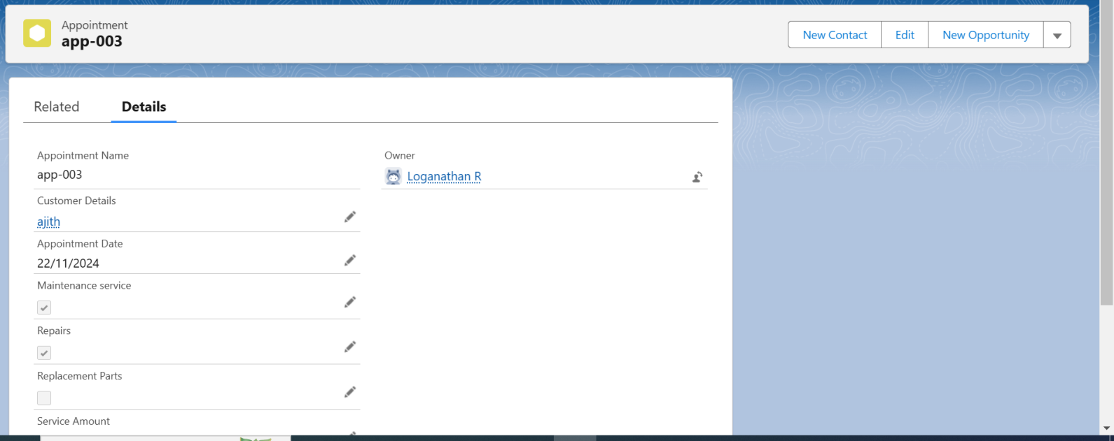

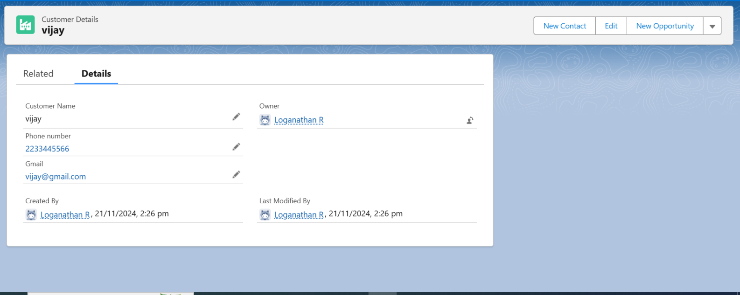

 

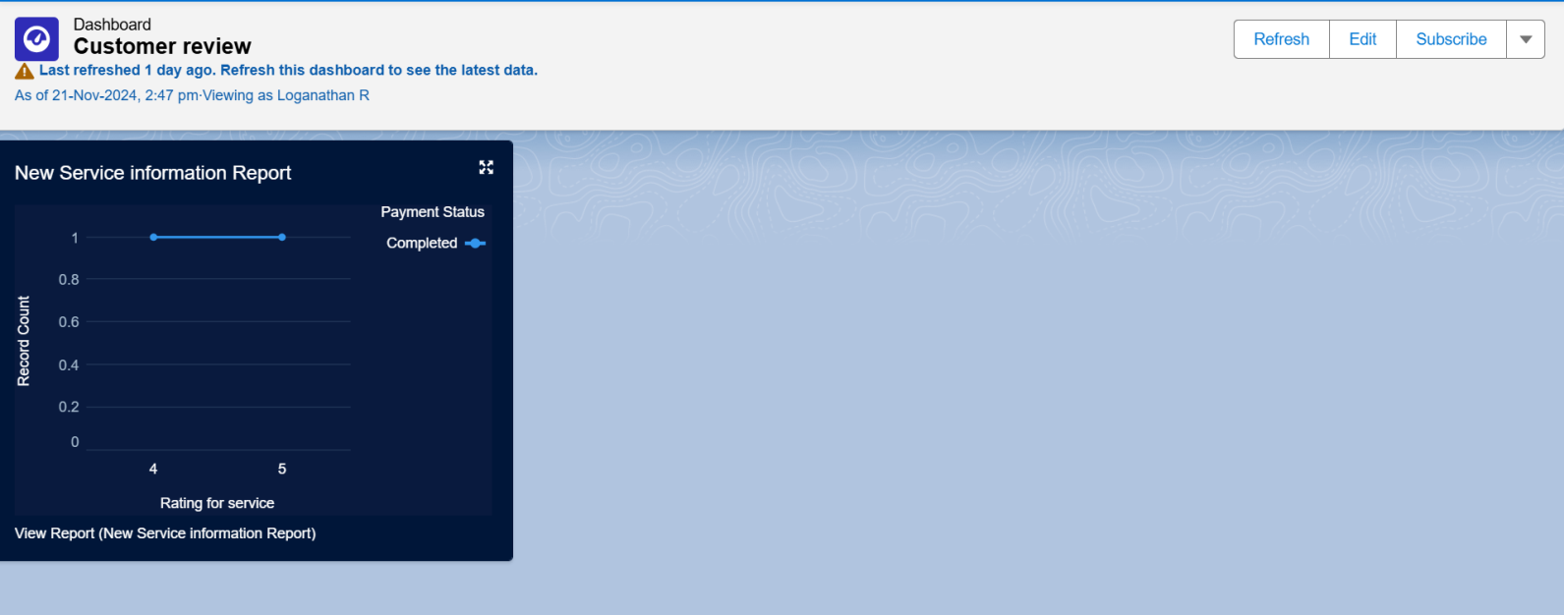

# Testing and Validation Unit Testing:

* Apex classes and triggers for inventory updates and booking confirmations.

# User Interface Testing:

* Validate that users can book services, view appointments, and manage inventory without errors.

# Integration Testing:

* Test seamless data flow between Salesforce and external systems like payment gateways.

# Appex class code:

public class AmountDistributionHandler {

public static void amountDist(list<Appointment c> listApp){ list<Service_records c> serList = new list <Service_records c>();

for(Appointment c app : listApp){

 

if(app.Maintenance_service c == true && app.Repairs c == true && app.Replacement_Parts c == true){

app.Service_Amount c = 10000;

}

else if(app.Maintenance_service c == true && app.Repairs c == true){ app.Service_Amount c = 5000;

}

else if(app.Maintenance_service c == true && app.Replacement_Parts c == true){

app.Service_Amount c = 8000;

}

else if(app.Repairs c == true && app.Replacement_Parts c == true){ app.Service_Amount c = 7000;

}

else if(app.Maintenance_service c == true){ app.Service_Amount c = 2000;

}

else if(app.Repairs c == true){ app.Service_Amount c = 3000;

}

else if(app.Replacement_Parts c == true){ app.Service_Amount c = 5000;

}

 

}

}

}

# Appex trigger code:

trigger AmountDistribution on Appointment c (before insert, before update) {

if(trigger.isbefore && trigger.isinsert || trigger.isupdate){ AmountDistributionHandler.amountDist(trigger.new);

}

}

# Key Scenarios Addressed by Salesforce in the Implementation Project

* Customer books a service online and receives an instant confirmation email.
* Garage staff receives real-time notifications for new bookings.
* Inventory automatically updates when parts are used for a service.
* Management accesses a dashboard showing monthly revenue and top-performing services.

# Conclusion

This project delivers a comprehensive Garage Management solution, integrating Salesforce's powerful features to enhance efficiency, customer satisfaction, and profitability. By automating processes and providing actionable insights, the project achieves its goal of optimizing garage operations.